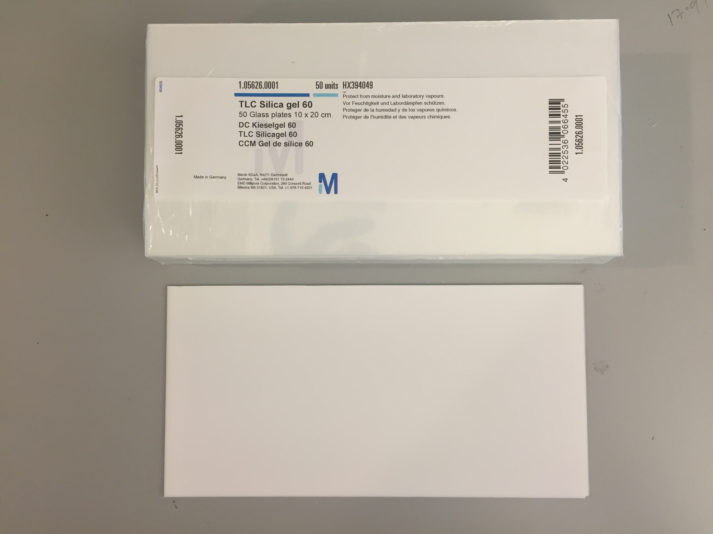

**Figure S1. TLC silica gel 60 plates**