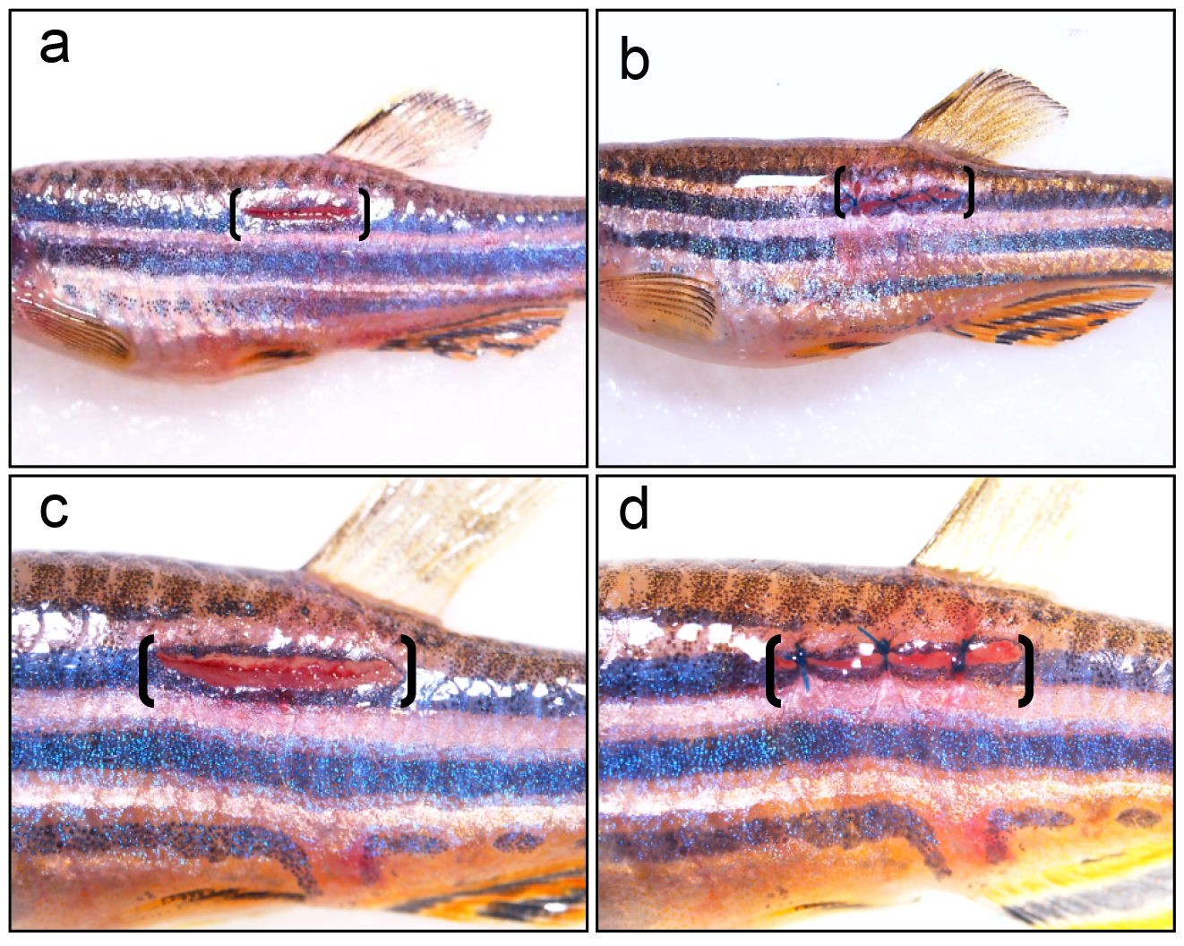

**Figure S1. Application of suture to close the wound after spinal cord injury.** a. Fish showing open wound at lateral side of the body after spinal cord injury. b. The wound has been closed after stitching. c. Higher magnification view of open wound. d. Higher magnification view of closed wound after stitching. Bracket indicates the wound area.