**Supplementary Video 1. Video showing a cell-cell junction labeled with E-cadherin-GFP (Figure 2) and ablated after the second time frame**

[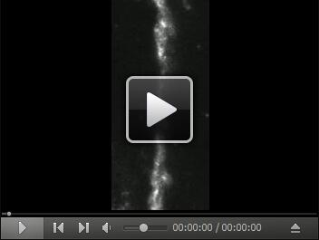](https://cdn.bio-protocol.org/journal/static/2068_Supplementary%20Video%201.avi?v=5922)