**Supplementary Video 2.** **Video showing the ablation of a cell-cell junction between cells expressing E-cadherin-GFP and soluble mCherry.** The video shows the ablation step caused membrane damage due to excessive laser power.

[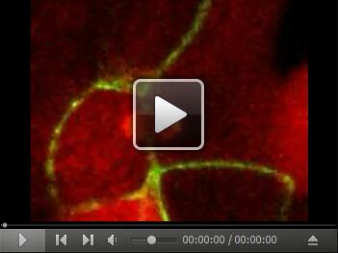](https://cdn.bio-protocol.org/journal/static/2068_Supplementary%20Video%202.avi?v=5957)