**Supplementary Video 3.** **Video showing the ablation of a cell-cell junction on cells expressing E-cadherin-GFP and soluble mCherry.** This video shows the case of a successful ablation without membrane damage (compare it with the Supplementary Video 2).

[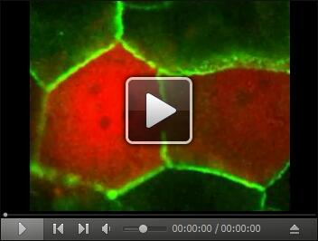](https://cdn.bio-protocol.org/journal/static/2068_Supplementary%20Video%203.avi?v=016)