**Supplementary Video 4. Large field of view showing the changes in junctional length of cell-cell contacts.** In particular, the cell-cell junction in the center of the movie was ablated. It is clear from this movie that ablation causes a dramatic change in junctional length compared to neighboring cell-cell junctions that have not been ablated. This show that ablation is conducted successfully

[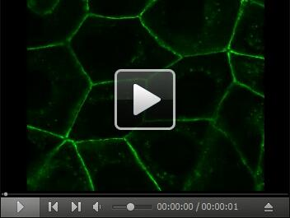](https://cdn.bio-protocol.org/journal/static/2068_Supplementary%20Video%204.avi?v=037)