**Video S1.** **Time-lapse movie displaying the spontaneous actin nucleation.** The actin concentration is 0.75 μM. Images were taken every 10 sec for 500 sec and were compressed into a 5 sec movie. Scale bar = 10 μm.

[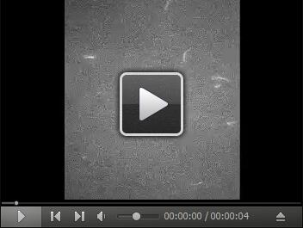](https://dl.dropboxusercontent.com/u/543333064/10192016/MOVIE%201.mov)

**Video S2.** **Time-lapse movie displaying the spontaneous actin nucleation in the presence of 1.5 μM PRF5.** The actin concentration is 0.75 μM. Images were taken every 10 sec for 500 sec and were compressed into a 5 sec movie. Scale bar = 10 μm.

[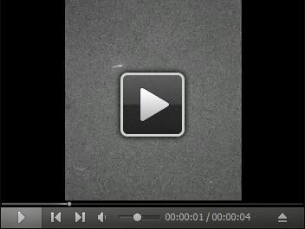](https://dl.dropboxusercontent.com/u/543333064/10192016/MOVIE%202.mov)

**Video S3.** **Time-lapse movie displaying the spontaneous actin nucleation in the presence of 0.9 μM FH5 and 1.5 μM PRF5.** The actin concentration is 0.75 μM. Images were taken every 10 sec for 500 sec and were compressed into a 5 sec movie. Scale bar = 10 μm.

[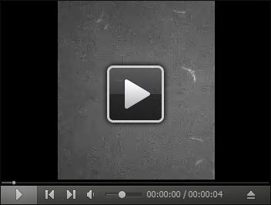](https://dl.dropboxusercontent.com/u/543333064/10192016/MOVIE%203.mov)