**Video S4. Time-lapse movie displaying the elongation of actin filaments.** The actin concentration is 0.75 μM. Images were taken every 10 sec for about 1,000 sec and were compressed into a 10 sec movie. Green and red arrows indicate the barbed and pointed end of a filament, respectively. Scale bar = 5 μm.

[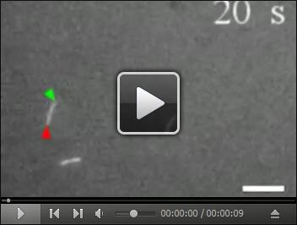](https://dl.dropboxusercontent.com/u/543333064/10192016/MOVIE%204.mov)

**Video S5. Time-lapse movie displaying the elongation of actin filaments in the presence of 0.75 μM PRF4.** The actin concentration is 0.75 μM. Images were taken every 10 sec for about 1,000 sec and were compressed into a 10 sec movie. Green and red arrows indicate the barbed and pointed end of a filament, respectively. Scale bar = 5 μm.

[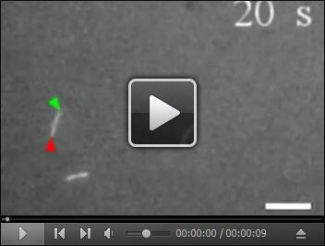](https://dl.dropboxusercontent.com/u/543333064/10192016/MOVIE%205.mov)

**Video S6. Time-lapse movie displaying the elongation of actin filaments in the presence of 0.75 μM PRF5.** The actin concentration is 0.75 μM. Images were taken every 10 sec for about 1,000 sec and were compressed into a 10 sec movie. Green and red arrows indicate the barbed and pointed end of a filament, respectively. Scale bar = 5 μm.

[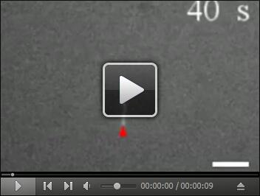](https://dl.dropboxusercontent.com/u/543333064/10192016/MOVIE%206.mov)