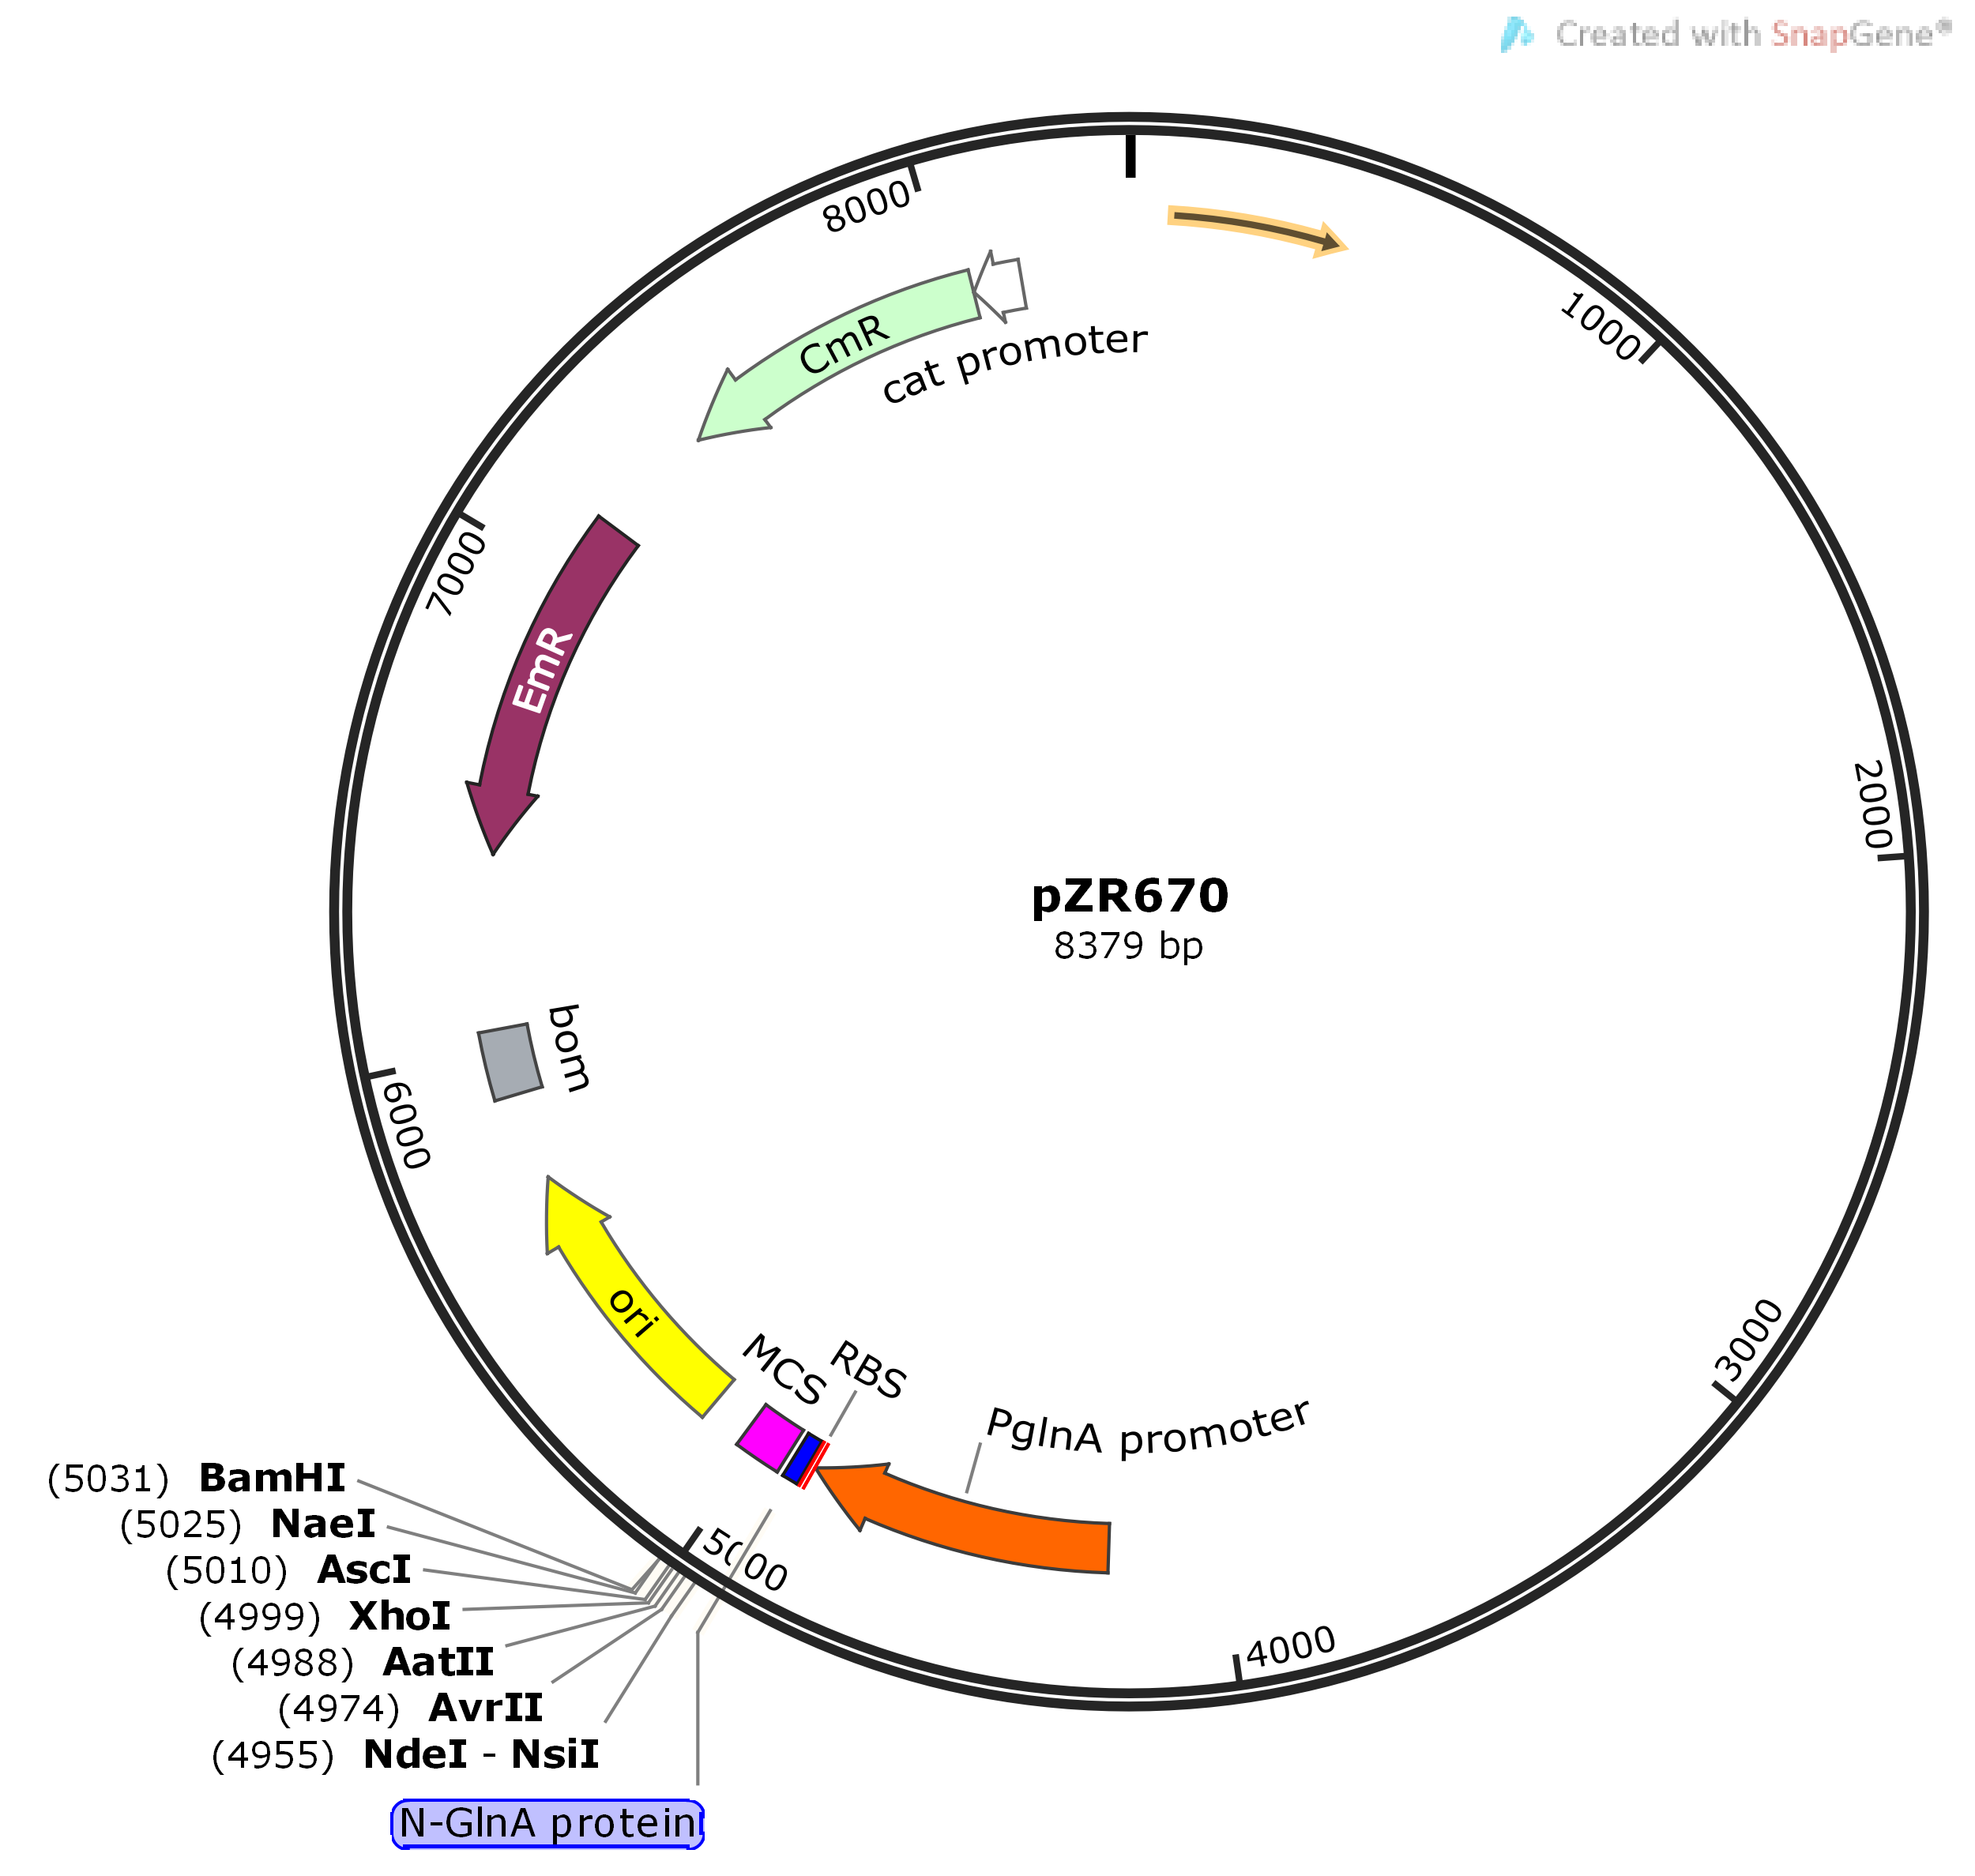
Figure S1. The map of pZR670 vector and its multiple cloning sites. CmR: chloramphenicol resistance; EmR: erythromycin resistance; bom: basis of movement; RBS: ribosomal binding site; MCS: multiple cloning sites.

