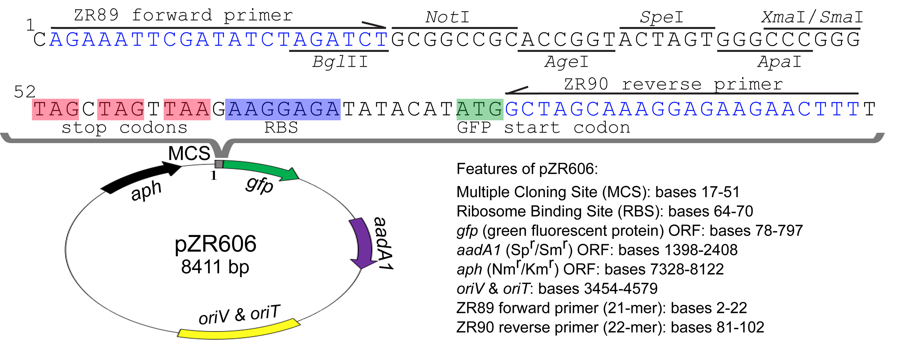

Figure S2. The map of pZR606 vector and its MCS. Primers ZR89 and ZR90 are for PCR verification of the insert in cargo plasmid.

