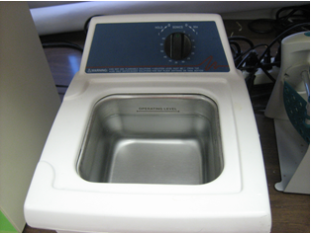
Figure S3. Branson 1510R-MT water bath sonicator

