Appendix I–3C library preparation

Agilent ScreenTape assessments
3C library:
After efficient ligation, the peak should be > 30 kb.
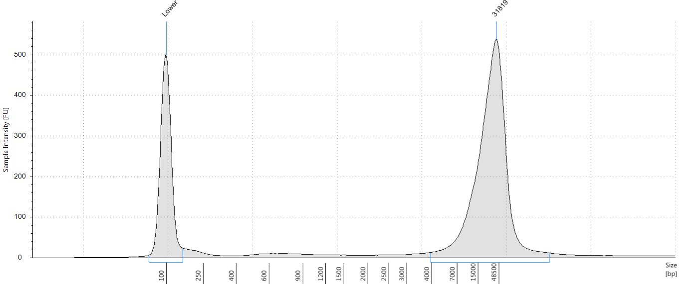

Digestion efficiency
Notes:
      - Either the Taqman or the SYBR assay can be used to assess digestion efficiency.
      - The primer sequences below are for mouse DNA. If using other species, two sets of primers should be designed: one pair spanning a DpnII restriction site, and one pair within a DpnII restriction fragment.
      - PCR conditions are optimized for the Applied Biosystems Step One Plus thermocycler and should be adapted for other machines.
      - Genomic DNA can be used as the undigested control. A dilution series of gDNA with the genomic primer can be used to determine DNA concentration.

Taqman Assay–Hba:
Mouse DpnII digestion efficiency:
Forward: GTGTCACCAAAACCAGCTCA (18 μM)
Reverse: CCTGGAATCCTTTGGCTCAAG (18 μM)
Probe: GGGCAGCTAAGATGCAAGTC (5 μM)
Mouse genomic control:
Forward: TGGAGGGCATATAAGTGCTACTTG (18 μM)
Reverse: TGCTTTTGTCTTCCCCAGAGA (18 μM)
Probe: TGCAGGTCCAAGACACTTCTGATTCTGACA (5 μM)
 | Volume
TaqMan Master Mix | 10 μl
Probe + Primers | 1 μl
Water | 7 μl
DNA (10 ng/μl) | 2 μl
Step | Temperature | Taqman
Step 1 | 50 °C | 2 min
Step 2 | 95 °C | 10 min
Step 3 | 95 °C | 15 sec
Step 4 | 60 °C | 60 sec
Step 5 | Go to Step 3 | 40 cycles

SYBR Assay–PKDREJ:
Mouse DpnII digestion efficiency:
Forward: GGAGAAAGAAGGCTGGTGTTAT
Reverse: TATCTGAGTTGGACAGCATTGG
Mouse genomic control:
Forward: TTATCTTGCATTTGCCAACTCG
Reverse: TGGGTTTCCCTGATTCTGAAA
 | Volume
2x KAPA SYBR (+ROX) | 10.4 μl
Primer mix (10μM) | 0.6 μl
Water | 7 μl
DNA (10 ng/μl) | 2 μl
Step | Temperature | SYBR
Step 1 | 95 °C | 20 sec
Step 2 | 95 °C | 3 sec
Step 4 | 60 °C | 30 sec
Step 4 | Go to Step 2 | 40 cycles
Step 5 | Melt curve | –

Example calculation:
 | Probe | CT | StDev | ∆CT  (DpnII-Genomic) | ∆∆CT  (C1-C2) | Digestion efficiency¹
gDNA | Genomic | 24.863 | 0.0897 | 0.397 | -2.475 | 82.013 %
gDNA | DpnII | 25.260 | 0.0245 | 0.397 | -2.475 | 82.013 %
3C-library | Genomic | 22.384 | 0.0399 | 2.872 | -2.475 | 82.013 %
3C-library | DpnII | 25.256 | 0.00751 | 2.872 | -2.475 | 82.013 %

¹ Efficiency = 100 x (1-2^{∆CT})

Appendix II–LI-Capture-C

Matching indices
NEBNext Primer Set 1: 1, 2, 3, 4, 5, 6, 7, 8, 9, 10, 11, 12
NEBNext Primer Set 2: 13, 14, 15, 16, 18, 19, 20, 21, 22, 23, 25, 27
Nimblegen HE-Oligo Kit A: 2, 4, 5, 6, 7, 12, 13, 14, 15, 16, 18, 19
Nimblegen HE-Oligo Kit B: 1, 3, 8, 9, 10, 11, 20, 21, 22, 23, 25, 27

Agilent ScreenTape assessments
Sonication:

Post Indexing PCR:

Appendix III–Tag-Capture-C

Index primers
Name | Primer Sequence
Ad1_universal | AATGATACGGCGACCACCGAGATCTACACTCGTCGGCAGCGTCAGATGTG
Ad2.1_TAAGGCGA | CAAGCAGAAGACGGCATACGAGATTCGCCTTAGTCTCGTGGGCTCGGAGATGT
Ad2.2_CGTACTAG | CAAGCAGAAGACGGCATACGAGATCTAGTACGGTCTCGTGGGCTCGGAGATGT
Ad2.3_AGGCAGAA | CAAGCAGAAGACGGCATACGAGATTTCTGCCTGTCTCGTGGGCTCGGAGATGT
Ad2.4_TCCTGAGC | CAAGCAGAAGACGGCATACGAGATGCTCAGGAGTCTCGTGGGCTCGGAGATGT
Ad2.5_GGACTCCT | CAAGCAGAAGACGGCATACGAGATAGGAGTCCGTCTCGTGGGCTCGGAGATGT
Ad2.6_TAGGCATG | CAAGCAGAAGACGGCATACGAGATCATGCCTAGTCTCGTGGGCTCGGAGATGT
Ad2.7_CTCTCTAC | CAAGCAGAAGACGGCATACGAGATGTAGAGAGGTCTCGTGGGCTCGGAGATGT
Ad2.8_CAGAGAGG | CAAGCAGAAGACGGCATACGAGATCCTCTCTGGTCTCGTGGGCTCGGAGATGT
Ad2.9_GCTACGCT | CAAGCAGAAGACGGCATACGAGATAGCGTAGCGTCTCGTGGGCTCGGAGATGT
Ad2.10_CGAGGCTG | CAAGCAGAAGACGGCATACGAGATCAGCCTCGGTCTCGTGGGCTCGGAGATGT
Ad2.11_AAGAGGCA | CAAGCAGAAGACGGCATACGAGATTGCCTCTTGTCTCGTGGGCTCGGAGATGT
Ad2.12_GTAGAGGA | CAAGCAGAAGACGGCATACGAGATTCCTCTACGTCTCGTGGGCTCGGAGATGT
(Buenrostro et al., 2013)

Agilent ScreenTape assessments
Tagmentation:

Post Indexing PCR:

