Supplementary Information

Appendix A: Software Setup and Calibration

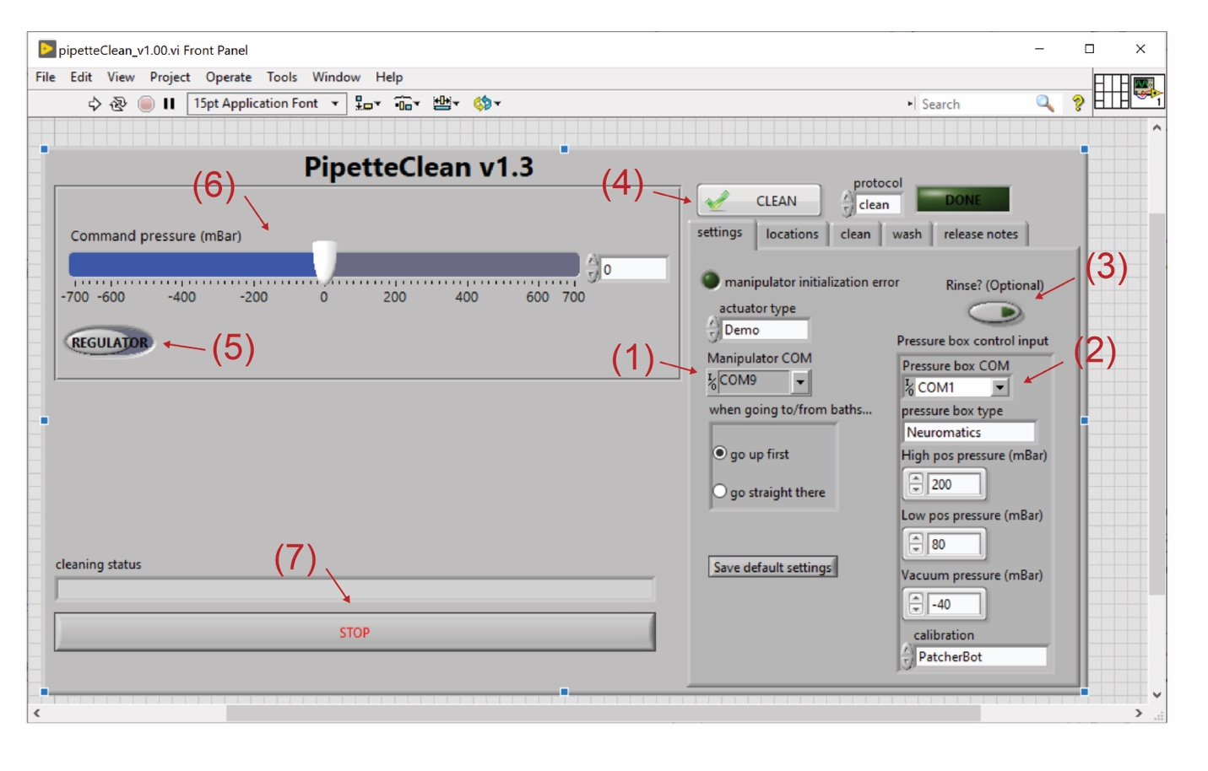
Figure S1. Layout of push-to-clean software. Front panel of push-to-clean software showing key features for setup. (1) Manipulator COM port to control movement. (2) Pressure box COM port to control pressure. (3) Toggle switch to turn the rinsing step (Procedure Step L) on or off. (4) “Clean” button that initiates automated pipette cleaning. (5) Toggle switch between pressure regulator and atmospheric pressure. (6) Slider showing command pressure in mbar. (7) Stop command to end program. Note: for actuators, this software is currently only available for use with Sutter and Scientifica manipulators; for pressure boxes, it is compatible with pressure boxes sold by Neuromatic Devices or detailed in our previous publications (Kodandaramaiah et al., 2009; Kolb et al., 2016 and 2019).
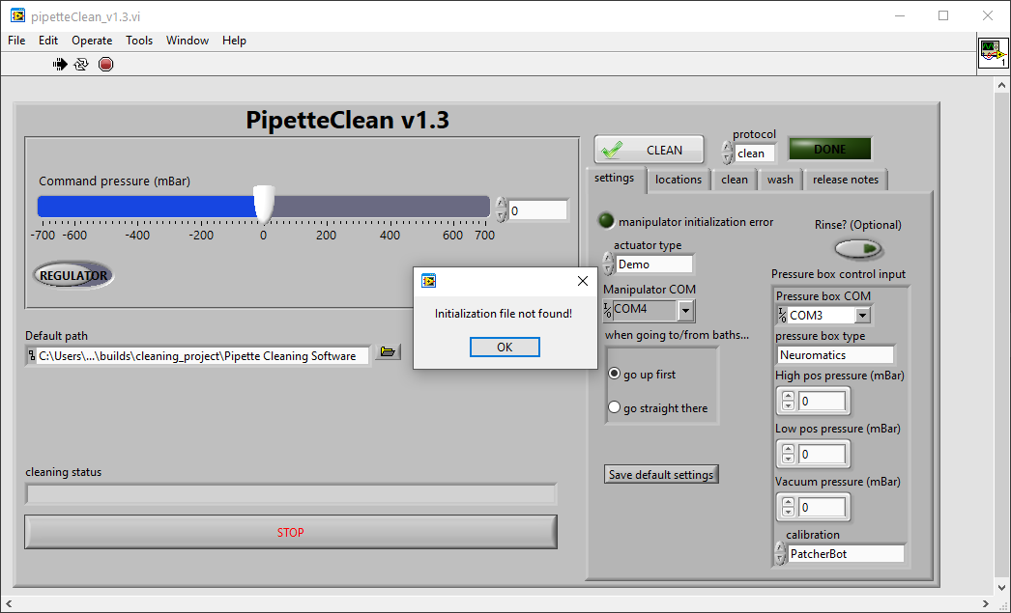
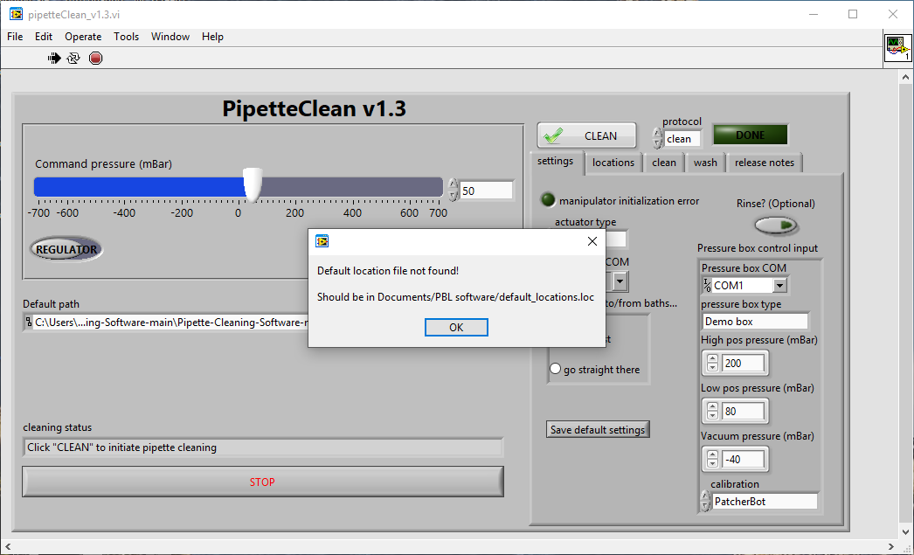
A
B
Figure S2: Initialization and setup of the software. To run the application for the first time, copy and paste the file path location of your (1) Pipette Cleaning Software. Then to start, press the (2) “Run” button. If it is your first time running the application, an (3) ‘Initialization file not found’ warning will pop up. Click “OK’ and then a (4) ‘Default location file not found’ warning will pop up. Click ‘OK’. Then, set the actuator type, manipulator COM port, pressure box COM port, and pressure box type (see S.Figure 1). Then press the (5) “Save default settings” button. Then, under the “locations” tab (see Figure 6), press the “Save locations” button. Stop the application by pressing the (6) “STOP” button. Now, restart the application and begin the steps of setting the clean locations as specified in the main manuscript. After the clean locations are set, the software is set to reuse your pipette after a patch clamp attempt.

Appendix B: Cleaning Dish CAD Files

Cleaning dishes can be custom manufactured to fit each individual microscope and stage. The following designs work well for the Olympus microscope platform supplied with the PatchStar 3000 electrophysiology rig (Scientifica).

File 1: “cleaningDish_v1.sldprt”
File 2: “cleaningDish_v2.sldprt”

Appendix C: Push-to-clean software

Software for push-to-clean can be downloaded directly as a LabView executable file from Github (https://github.com/mightenyip/Pipette-Cleaning-Software).

