Appendix

User guide for CSE Assessment Interface

- Probe Section
- Measurement Selection: Choose what is displayed in the first two plots:
- EMG 50 Hz highpass filter + Cortex Trigger
- EMG with a DC Component removed
- EMG 50 Hz HP + Muscle Trigger
- EMG DC removed + Muscle Trigger
- Cortex stim: checking this box enables the DAQ DIO ports 52/53, driving the first A-M system stimulator, wired via the breakout board to the chosen cortical electrodes.
- Muscle stim: checking this box enables the DAQ DIO port 17/50, driving the second A-M system stimulator, wired via the breakout board to the chosen intramuscular electrodes.
- Trains: The number of trains or single pulses to deliver in total.
- Inter-Train Time (s): The period of time between trains or single pulses of stimulation during the probes.
- Before Stim (ms): Time interval relative to the onset of the TTL signal for capturing the snip. This sets the start point (in ms) for recording the captured data of a single EMG response, and is linked to the TTL onset. See Figure S1.

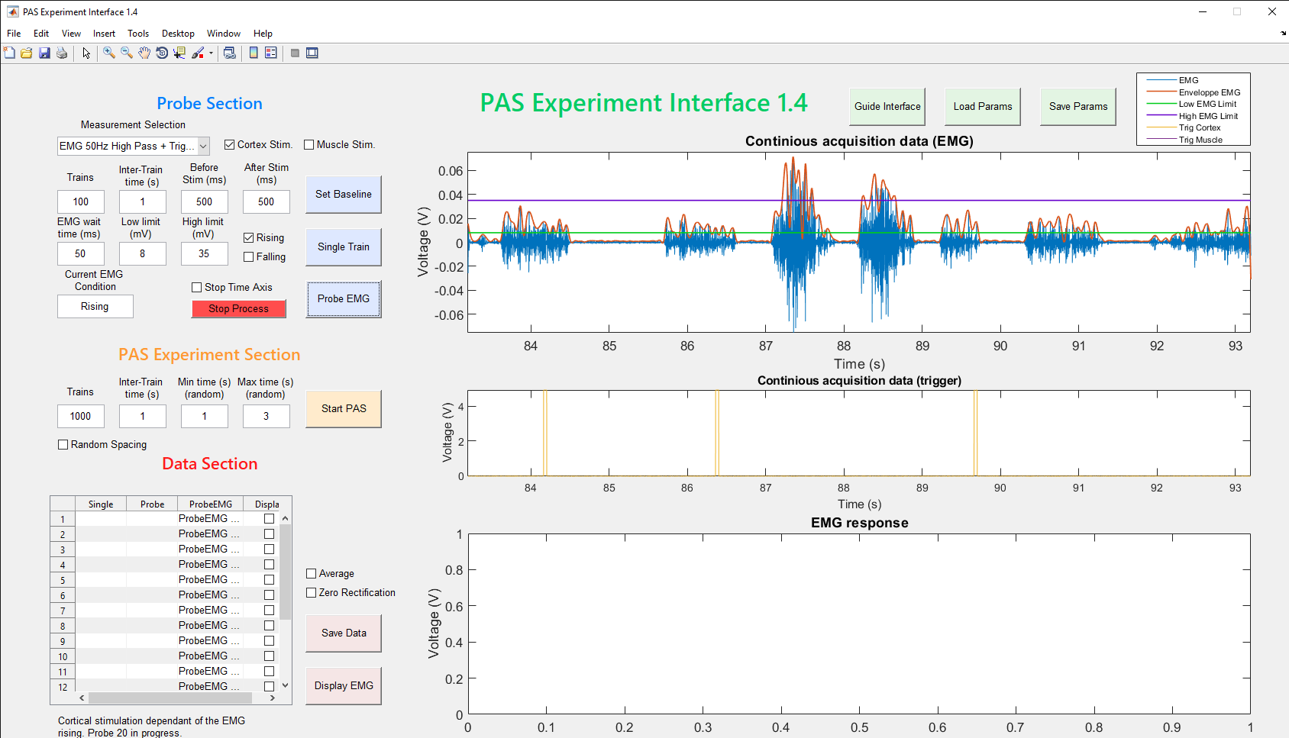
Figure S1. Graphical User Interface (GUI) for Corticospinal Excitability Assessment and Paired Associative Stimulation. This illustrates the GUI’s operation during a probe session. Trigger signals (yellow 5 V, within continuous acquisition data (trigger) box) indicate when the EMG (blue signal, from a human for demonstration purposes) fits within the predefined conditions set in the input boxes to the left. Red trace indicates the envelope calculated based on the EMG signal; green and red are the user-defined low and high limits, respectively.

- After Stim (ms): Similarly, sets the end point (in ms) the recorded snip, again relative to the onset of the TTL.
- EMG Wait Time (ms): This is a user-specified period of time to trigger stimulation, for calculating the average EMG envelope. The average is tested against the envelope criteria to determine whether to probe stim or not. For example, a 50 ms EMG wait time means that the software calculates the average EMG level from the previous 50 ms of data collected, and the stimulation criteria must be fulfilled for the duration of this time interval in order to stimulate.
- Low Limit (mV): Lowest limit of the EMG window amplitude defined by the user to stimulate during closed-loop probes.
- High Limit (mV): Highest limit of the EMG window amplitude defined by the user to stimulate during closed-loop probes.
- For a previous experiment (Ting et al., 2020), since we required a minimal EMG level before triggering cortical stimulation for CSE assessment, the Low Limit value corresponded to two standard deviations above the average of the EMG envelope during rest. The High Limit value corresponded to twelve standard deviations above resting EMG.
- Current EMG Condition: Displays whether the current EMG signal is rising from below or falling from above the specified EMG window.
- Rising/Falling: Allows the user to require a specific phase of EMG activity (rising from below or falling from above the target window) for stimulation to occur.
- Stop Time Axis: Stop the visuals from updating in real time. Acquisition continues, but the graphical elements are not continually refreshed.
- Set Baseline: Hitting this button defines the baseline EMG amplitude as the mean value of the upper envelope of the EMG signal for the past second. This value, along with the standard deviation of the signal for that period, are displayed to the user as a reference to define the required EMG window lower and upper limits. For best results, the baseline should be calculated while the animal is in a resting state.
- Single Train: This sends a TTL signal to either or both stimulators, based on checkbox selection.
- Probe EMG: This button starts the automated closed-loop CSE assessment process. It sends out the specified number of stimulator triggers at the specified frequency, based on the ongoing amplitude of the EMG envelope signal and requirement settings. The program waits until the envelope is within the minimum and maximum ranges specified for the desired duration (EMG wait time). If specified, the rising or falling phase of the EMG is also considered for stimulation.
- Stop Process: Stops the Probe EMG process regardless of whether the stimulation program is complete.

- PAS Experiment Section
- Trains: User can specify the number of trains (stimulation triggers) that will make up the PAS program.
- Inter-Train Time (s): The period of time between pairs of stimulation during PAS (for single pulse protocols, for example, this would be the time in seconds between electrical pulses. For pairs of trains, it will be time to wait between the onset of each train).
- Min Time (s) and Max Time (s) Random Spacing: User can choose whether the time interval between the electrical pulses in a train are constant or randomly determined. Setting identical intervals for Min Time and Max Time results in a fixed interval between stimulation pairs, otherwise these values are used as upper- and lower-bounds for automatic generation of a pseudo-random interval from a uniform distribution between them.

- Data Section
- Table: Lists all of the stimulations produced.
- Save Data: Export the EMG captures to the active MATLAB workspace
- Display: Visualizes the existing captures. DIO input port 67/68.
- Zero Rectification: Zeroes the time axis of the capture, relative to the start of the TTL signal; this option is for display purposes only and has no effect on the raw data. This option is only available during data capture.
- Average: Displays the average of the responses obtained over several captures, only available during data capture.

- Other Options
- Interface Guide: Displays a figure explaining the different components of the interface.
- Save Params: User can save the stimulation parameters in a file.
- Load Params: User can load stimulation parameters in a previously saved file.

