Supplementary Figures Raw images for testing out scoring algorithms. See also Figure 2.

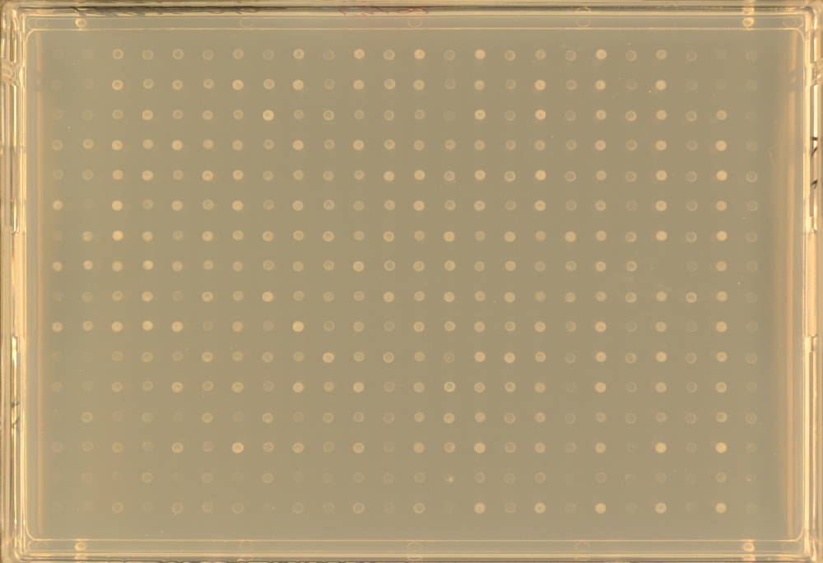
Figure S1. Example plate exposed to light photographed at day 0.

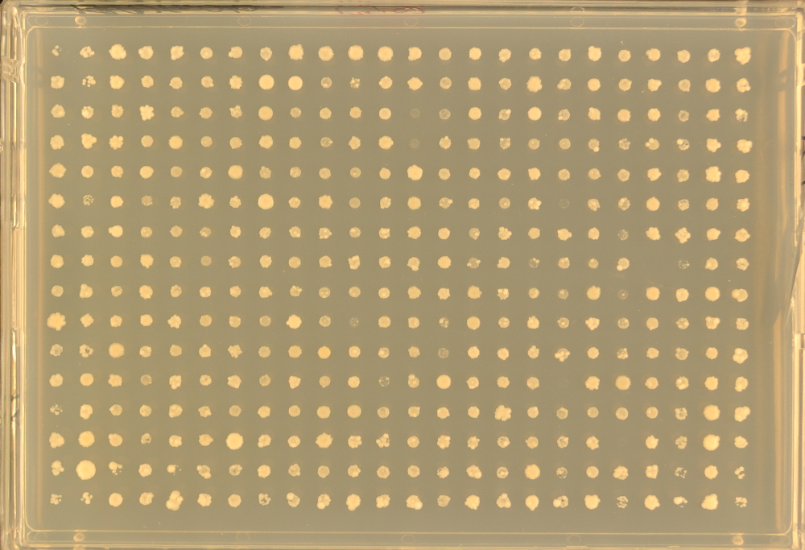
Figure S2. Example plate exposed to light photographed at day 6.

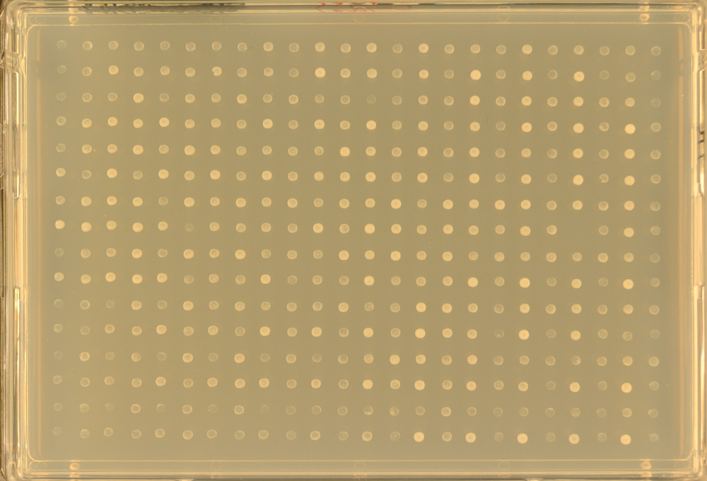
Figure S3. Example plate incubated in the dark photographed at day 0.

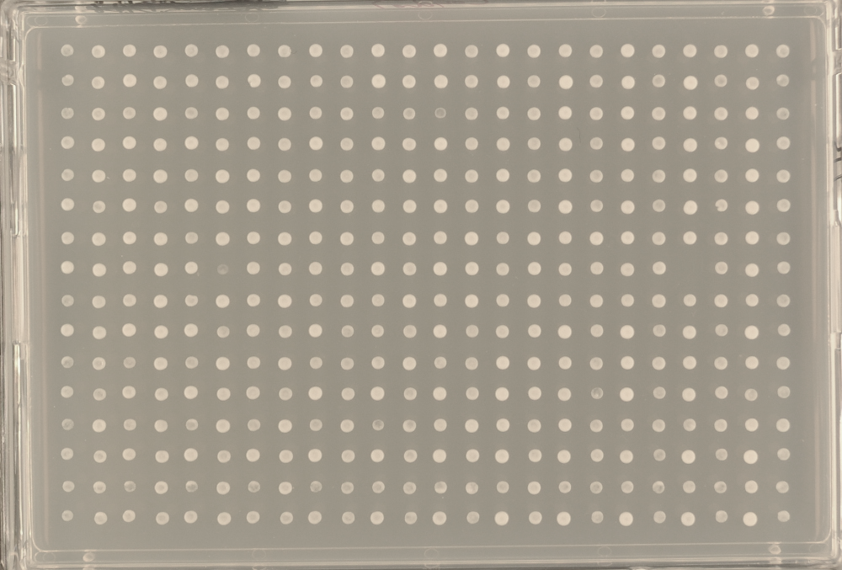
Figure S4. Example plate incubated in the dark photographed at day 1.

